**Prelab 5 Basic Filters and Frequency Response**

**Nolan Anderson**

**February 16, 2021**

---------------------------------------------------------------------------------------

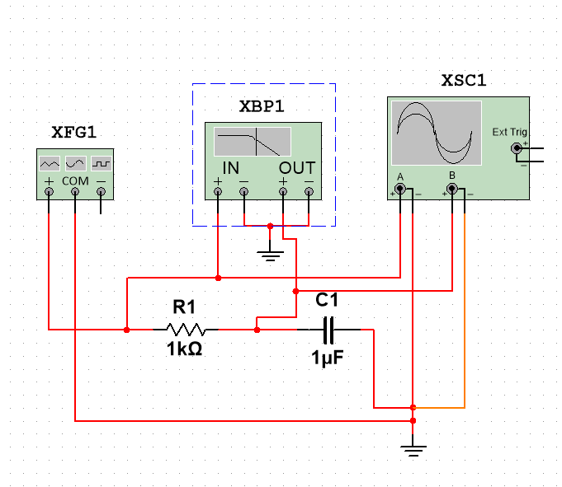

**Circuit 1: Low Pass Filter**

**Part 1 – Low Pass Filter**

Let R = 1kΩ, C = 1 µF, varying frequency, VIN = 4Vpp sinusoidal

**1. Fill up a table similar to the one given below.**

|  |  |  |
| --- | --- | --- |
|  | Simulated | |
| f (Hz) | Gain (dB) | Phase Angle (°) |
| 25 | 0.158651 | 9 |
| 50 | -0.32627 | 17 |
| 75 | -0.83987 | 25 |
| 100 | -1.57562 | 32 |
| 150 | -3.03537 | 44 |
| 200 | -4.45033 | 52 |
| 300 | -6.72919 | 65 |
| 500 | -10.6056 | 71 |
| 600 | -11.7654 | 75 |
| 700 | -12.7498 | 77 |
| 800 | -13.8601 | 79 |
| 900 | -14.688 | 80 |
| 1000 | -15.6031 | 81 |

Table 1: Low Pass Filter Frequency, Gain, Phase Angle

**2. Plot gain in dB vs. frequency.**

|  |
| --- |
|  |

Figure 1: Low Pass Filter Gain vs Frequency

**3. Plot phase vs. frequency.**

|  |
| --- |
|  |

Figure 2: Low Pass Filter Phase vs. Frequency

**5. Determine the cutoff frequency from your tabulated data you made in step 1. Compare it with the theoretical value. Mark the cutoff frequency on your magnitude plot.**

|  |
| --- |
| fc (theoretical cut off) = ½*pi*R*C = 1/(6.28*103*10-6) = **157 Hz**  fc (simulated cut off) ≈ 147 Hz |

---------------------------------------------------------------------------------------

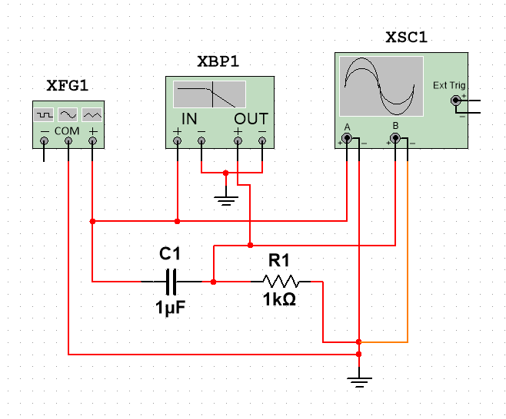

**Circuit 2: High Pass Filter**

**Part 2 – High Pass Filter**

Let R = 1kΩ, C = 1 µF, varying frequency, VIN = 4Vpp sinusoidal

**1. Fill up a table similar to the one given below.**

|  |  |  |
| --- | --- | --- |
|  | Simulated | |
| f (Hz) | Gain (dB) | Phase Angle (°) |
| 25 | -13.8601 | 81 |
| 50 | -9.11292 | 72 |
| 75 | -6.64277 | 65 |
| 100 | -4.79099 | 58 |
| 150 | -2.8112 | 46 |
| 200 | -1.96827 | 38 |
| 300 | -1.19996 | 28 |
| 500 | -0.49412 | 18 |
| 600 | -0.49412 | 15 |
| 700 | -0.49412 | 14 |
| 800 | -0.32627 | 11 |
| 900 | -0.24355 | 10 |
| 1000 | -0.1616 | 9 |

Table 2: High Pass Filter Frequency, Gain, Phase Angle

**2. Plot gain in dB vs. frequency.**

|  |
| --- |
|  |

Figure 3: High Pass Filter Gain vs Frequency

**3. Plot phase vs. frequency.**

|  |
| --- |
|  |

Figure 4: High Pass Filter Phase vs. Frequency

**5. Determine the cutoff frequency from your tabulated data you made in step 1. Compare it with the theoretical value. Mark the cutoff frequency on your magnitude plot.**

|  |
| --- |
| fc (theoretical cut off) = ½*pi*R*C = 1/(6.28*103*10-6) = **157 Hz**  fc (simulated cut off) ≈ 147 Hz |

---------------------------------------------------------------------------------------

**Appendix**

|  |
| --- |
|  |

A1 – Low Pass Filter Gain Bode Plotter

|  |
| --- |
|  |

A2 – Low Pass Filter Phase Bode Plotter

|  |
| --- |
|  |

A3 – High Pass Filter Gain Bode Plotter

|  |
| --- |
|  |

A4 – High Pass Filter Phase Bode Plotter